**Supply Chain Management User**

**Authentication System**

A Course End Project Report

**Database Management Systems Laboratory (****A8517)**

In partial fulfillment of the requirements for the

award of the degree of

**BATCHELOR OF TECHNOLOGY**

**IN**

**COMPUTER SCIENCE AND ENGINEERING**

Submitted By

M. Uday Kiran – 22881A05N4

Under the guidance of

**Dr. Vasantha SV**

Associate Professor

Department of Computer Science and Engineering



**DEPARTMENT OF COMPUTER SCIENCE AND ENGINEERING**

**VARDHAMAN COLLEGE OF ENGINEERING**

(AUTONOMOUS)

Affiliated to JNTUH, Approved by AICTE, Accredited by NAAC with A++ Grade, ISO 9001:2015 Certified Kacharam, Shamshabad, Hyderabad – 501218, Telangana, India.

**June, 2024**

**VARDHAMAN COLLEGE OF ENGINEERING**

(AUTONOMOUS)

Affiliated to JNTUH, Approved by AICTE, Accredited by NAAC with A++ Grade, ISO 9001:2015 Certified Kacharam, Shamshabad, Hyderabad – 501218, Telangana, India.

**DEPARTMENT OF COMPUTER SCIENCE AND ENGINEERING**



**CERTIFICATE**

This is to certify that the Course End Project titled **“Supply Chain Management User**

**Authentication System”** is carried out by **Mr. M. Uday Kiran,** Roll Number **22881A05N4** towards **A8517 –** **Database Management Systems Laboratory** course and submitted to the **Department of Computer Science and Engineering**, in partial fulfillment of the requirements for the award of the degree of **Bachelor of Technology** in the **Department of Computer Science and Engineering** during the Academic year 2023-24.

**Instructor: Head of the Department:**

**Dr. Vasantha SV, Dr. Ramesh Karnati,**

Associate Professor, Head of the Department,

Dept of Computer Science and Dept. of Computer Science and

Engineering, Engineering,

Vardhaman College of Engineering, Vardhaman College of Engineering,

Hyderabad. Hyderabad.

**ACKNOWLEDGEMENT**

The satisfaction that accompanies the successful completion of the task would be incomplete without the mention of the people who made it possible, whose constant guidance and encouragement crown all the efforts with success.

We wish to express our deep sense of gratitude to **Ms.** **Dr. Vasantha SV**, Associate Professor, Department of Computer Science and Engineering, Vardhaman College of Engineering, for her able guidance and useful suggestions, which helped us in completing the design part of a potential project in time.

We are particularly thankful to **Dr. Ramesh Karnati**, Associate Professor & Head, Department of Computer Science and Engineering for his guidance, intense support, and encouragement, which helped us to mold our project into a successful one.

We show gratitude to our honorable Principal **Dr. J.V.R.Ravindra**, for having provided all the facilities and support.

We avail this opportunity to express our deep sense of gratitude and heartfelt thanks to **Dr. Teegala Vijender Reddy**, Chairman, and **Sri Teegala Upender Reddy**, Secretary of VCE, for providing a congenial atmosphere to complete this project successfully.

We also thank all the staff members of Computer Science and Engineering for their valuable support and generous advice. Finally, thanks to all our friends and family members for their continuous support and enthusiastic help.

**Uday Kiran Makineni (22881A05N4)**

**Project Title: Supply Chain Management User**

**Authentication System**

**Developed by**

**Roll No: 22881A05N4**

**Name: M. Uday Kiran**

**Class: II B.Tech. CSE-D**

**Regulation: R22**

**Under the Guidance of**

**Dr. Vasantha SV, Associate Professor**

**CSE Dept.**

**Github Link:** [**https://github.com/achiever2004/supply_chain_management_system**](https://github.com/achiever2004/supply_chain_management_system)

**Abstract**

This project involves developing a user authentication and management system for a supply chain management application. The system comprises a registration (signup) process, a login mechanism, and a role-based dashboard display. The project utilizes the XAMPP control panel to manage Apache and MySQL software packages, enabling the hosting of the web application on a local server.

**Problem Statement**

The goal of this project is to create a secure and efficient registration and login system for a supply chain management system. The system should:

1. Allow users to register with their personal information and position within the supply chain.
2. Encrypt user passwords and data before storing them in the database.
3. Decrypt passwords and data during login to authenticate users.
4. Display different dashboards based on the user's position.
5. To Use local server hosting for development and testing.

**Explanation of Logic**

**Registration**

1. Users fill out a registration form with their details.
2. The passwords and data is encrypted.
3. Encrypted passwords and data and other user details are stored in a MySQL database.

**Login**

1. Users enter their username and password in the login form.
2. The system retrieves the encrypted password from the database.
3. The stored password is decrypted.
4. If the decrypted password matches the entered password, the user is authenticated.
5. Based on the user's position, the corresponding dashboard is displayed.

**Key Features**

1. User Registration: Secure storage of user details with encryption of data while storing and retrieving.
2. User Login: Decryption of passwords for authentication.
3. Role-Based Dashboard: Different UI for different user roles (manager, employee, supplier).
4. Data Security: We are not stored the data of a user into the database directly, rather we encrypted the data before storing into the database and we decrypted the user data while retrieving from database.
5. Local Hosting with XAMPP: Development and testing on a local server environment.

**Implementation Process**

**Prerequisites**

1. XAMPP: Installed XAMPP to set up Apache and MySQL on our local machine.

**Steps**

1. **Install XAMPP**

Downloaded and installed XAMPP from Apache Friends. Start Apache and MySQL services using the XAMPP control panel.

1. **Set Up Database**

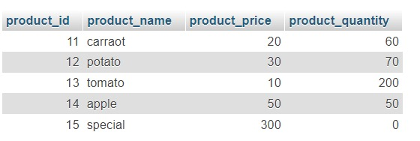

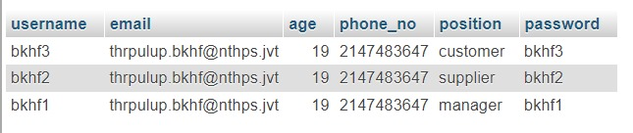

1. **Create Registration Form (signup.php)**

<?php

function encrypt($data) {

$result = '';

$shift = 7;

for ($i = 0; $i < strlen($data); $i++) {

$char = $data[$i];

if (ctype_alpha($char)) {

$ascii = ord($char);

$offset = ctype_upper($char) ? 65 : 97;

$result .= chr(($ascii + $shift - $offset) % 26 + $offset);

} else {

$result .= $char;

}

}

return $result;

}

function decrypt($data) {

$result = '';

$shift = 7;

for ($i = 0; $i < strlen($data); $i++) {

$char = $data[$i];

if (ctype_alpha($char)) {

$ascii = ord($char);

$offset = ctype_upper($char) ? 65 : 97;

$result .= chr(($ascii - $shift - $offset + 26) % 26 + $offset);

} else {

$result .= $char;

}

}

return $result;

}

session_start();

// Database configuration

$servername = "localhost";

$username = "root";

$password = "";

$dbname = "supply";

$port = 3307; // New port number you set

$signup_successful = false;

// Create connection

$conn = new mysqli($servername, $username, $password, $dbname, $port);

// Check connection

if ($conn->connect_error) {

die("Connection failed: " . $conn->connect_error);

}

// Get form data

$username = encrypt($_POST['username']);

$email = encrypt($_POST['email']);

$age = encrypt($_POST['age']);

$phone = encrypt($_POST['phone']);

$position = $_POST['position'];

$password = encrypt($_POST['password']);

// SQL query to insert data into database

$sql = "INSERT INTO users (username, email, age, phone_no, position, password) VALUES ('$username', '$email', '$age', '$phone', '$position', '$password')";

if ($conn->query($sql) === TRUE) {

http_response_code(200); // Success

$signup_successful = true;

} else {

http_response_code(500); // Server error

echo "Error: " . $sql . "<br>" . $conn->error;

}

$conn->close();

?>

<!DOCTYPE html>

<html lang="en">

<head>

<meta charset="UTF-8">

<meta name="viewport" content="width=device-width, initial-scale=1.0">

<title>Sign In</title>

<style>

body {

font-family: Arial, sans-serif;

background-color: #f2f2f2;

display: flex;

justify-content: center;

align-items: center;

height: 100vh;

flex-direction: column;

}

.container {

background-color: white;

padding: 20px;

border-radius: 5px;

box-shadow: 0px 0px 10px 0px rgba(0, 0, 0, 0.1);

margin-bottom: 20px;

}

.container h2 {

margin-bottom: 20px;

}

.container input[type="text"], .container input[type="password"] {

width: 100%;

padding: 10px;

margin: 10px 0;

border: 1px solid #ccc;

border-radius: 5px;

}

.container input[type="submit"] {

width: 100%;

padding: 10px;

border: none;

background-color: #4CAF50;

color: white;

border-radius: 5px;

cursor: pointer;

}

.container input[type="submit"]:hover {

background-color: #45a049;

}

.welcome-section {

display: none;

text-align: center;

}

.error {

color: red;

}

</style>

</head>

<body>

<?php if ($signup_successful): ?>

<div class="welcome-section" id="welcome-section">

<h2>Welcome to our world!!!</h2>

<p>You have successfully signed up </p>

</div>

<script>

document.addEventListener('DOMContentLoaded', function() {

document.getElementById('welcome-section').style.display = 'block';

});

</script>

<?php else: ?>

<div class="container">

<h2>Log in </h2>

<form action="signin.php" method="post">

<label for="username">Username:</label>

<input type="text" id="username" name="username" required>

<label for="password">Password:</label>

<input type="password" id="password" name="password" required>

<input type="submit" value="Sign In">

<?php if ($error_message): ?>

<p class="error"><?php echo $error_message; ?></p>

<?php endif; ?>

</form>

</div>

<?php endif; ?>

</body>

</html>

1. **Create Login Form (signin.php)**

<?php

function encrypt($data) {

$result = '';

$shift = 7;

for ($i = 0; $i < strlen($data); $i++) {

$char = $data[$i];

if (ctype_alpha($char)) {

$ascii = ord($char);

$offset = ctype_upper($char) ? 65 : 97;

$result .= chr(($ascii + $shift - $offset) % 26 + $offset);

} else {

$result .= $char;

}

}

return $result;

}

function decrypt($data) {

$result = '';

$shift = 7;

for ($i = 0; $i < strlen($data); $i++) {

$char = $data[$i];

if (ctype_alpha($char)) {

$ascii = ord($char);

$offset = ctype_upper($char) ? 65 : 97;

$result .= chr(($ascii - $shift - $offset + 26) % 26 + $offset);

} else {

$result .= $char;

}

}

return $result;

}

session_start();

$servername = "localhost";

$username = "root";

$password = "";

$dbname = "supply";

$port = 3307;

$conn = new mysqli($servername, $username, $password, $dbname, $port);

if ($conn->connect_error) {

die("Connection failed: " . $conn->connect_error);

}

$login_successful = false;

$error_message = "";

if ($_SERVER["REQUEST_METHOD"] == "POST") {

$inputUsername = encrypt($_POST['username']);

$inputPassword = encrypt($_POST['password']);

$sql = "SELECT username, password, position FROM users WHERE username = ?";

$stmt = $conn->prepare($sql);

$stmt->bind_param("s", $inputUsername);

$stmt->execute();

$result = $stmt->get_result();

if ($result->num_rows > 0) {

$row = $result->fetch_assoc();

if ($inputPassword === $row['password']) {

$_SESSION['username'] = $inputUsername;

$_SESSION['position'] = $row['position'];

$login_successful = true;

$decrypted_name = decrypt($row["username"]);

} else {

$error_message = "Invalid password.";

}

} else {

$error_message = "No user found with that username.";

}

$stmt->close();

}

$conn->close();

?>

<!DOCTYPE html>

<html lang="en">

<head>

<meta charset="UTF-8">

<meta name="viewport" content="width=device-width, initial-scale=1.0">

<title>Sign In</title>

<style>

body {

font-family: Arial, sans-serif;

background-color: #f2f2f2;

display: flex;

justify-content: center;

align-items: center;

height: 100vh;

flex-direction: column;

}

.container {

background-color: white;

padding: 20px;

border-radius: 5px;

box-shadow: 0px 0px 10px 0px rgba(0, 0, 0, 0.1);

margin-bottom: 20px;

width: 300px;

}

.container h2 {

margin-bottom: 20px;

text-align: center;

}

.container input[type="text"], .container input[type="password"] {

width: 100%;

padding: 10px;

margin: 10px 0;

border: 1px solid #ccc;

border-radius: 5px;

}

.container input[type="submit"] {

width: 100%;

padding: 10px;

border: none;

background-color: #4CAF50;

color: white;

border-radius: 5px;

cursor: pointer;

}

.container input[type="submit"]:hover {

background-color: #45a049;

}

.welcome-section, .customer-page, .supplier-page, .manager-page {

display: none;

text-align: center;

}

.section {

margin: 20px 0;

}

.section button {

padding: 10px 20px;

margin-top: 10px;

border: none;

border-radius: 5px;

background-color: #4CAF50;

color: white;

cursor: pointer;

}

.section button:hover {

background-color: #45a049;

}

.error {

color: red;

text-align: center;

}

</style>

<script>

function navigateToResultPage() {

window.location.href = 'construct.html';

}

function navigateToPeoplePage(){

window.location.href = 'users.php'

}

function navigateToProductPage(){

window.location.href = 'result.php'

}

function navigateToManagePage(){

window.location.href = 'manage.php'

}

function navigateToCustomerPage(){

window.location.href = 'customer.php'

}

function navigateToSupplyPage(){

window.location.href = 'supply.php'

}

</script>

</head>

<body>

<?php if ($login_successful): ?>

<?php if ($_SESSION['position'] === 'customer'): ?>

<div class="customer-page" id="customer-page">

<h2>Welcome, <?php echo htmlspecialchars($decrypted_name); ?>!</h2>

<p>You have successfully logged in as a customer.</p>

<div class="section" id="order-history">

<h2>Place Order</h2>

<p>Place your order here </p>

<button onclick="navigateToCustomerPage()">Place Order</button>

</div>

<div class="section" id="tracking">

<h2>Tracking</h2>

<p>Track your current orders.</p>

<button onclick="navigateToResultPage()">Track Orders</button>

</div>

<div class="section" id="account-details">

<h2>Account Details</h2>

<p>Manage your account information.</p>

<button onclick="navigateToManagePage()">Manage Account</button>

</div>

<div class="section" id="support">

<h2>Support</h2>

<p>Contact support for help.</p>

<button onclick="navigateToResultPage()">Contact Support</button>

</div>

</div>

<?php elseif ($_SESSION['position'] === 'supplier'): ?>

<div class="supplier-page" id="supplier-page">

<h2>Welcome, <?php echo htmlspecialchars($decrypted_name); ?>!</h2>

<p>You have successfully logged in as a supplier.</p>

<div class="section" id="inventory">

<h2>Inventory Management</h2>

<p>Manage your inventory and stock levels.</p>

<button onclick="navigateToProductPage()">Manage Inventory</button>

</div>

<div class="section" id="orders">

<h2>Orders</h2>

<p>View and manage incoming orders.</p>

<button onclick="navigateToSupplyPage()">View Orders</button>

</div>

<div class="section" id="account-details">

<h2>Account Details</h2>

<p>Manage your account information.</p>

<button onclick="navigateToManagePage()">Manage Account</button>

</div>

<div class="section" id="support">

<h2>Support</h2>

<p>Contact support for help.</p>

<button onclick="navigateToResultPage()">Contact Support</button>

</div>

</div>

<?php elseif ($_SESSION['position'] === 'manager'): ?>

<div class="manager-page" id="manager-page">

<h2>Welcome, <?php echo htmlspecialchars($decrypted_name); ?>!</h2>

<p>You have successfully logged in as a manager.</p>

<div class="section" id="overview">

<h2>Business Overview</h2>

<p>View overall business performance and metrics.</p>

<button onclick="navigateToProductPage()">View Overview</button>

</div>

<div class="section" id="manage-employees">

<h2>Manage Employees</h2>

<p>View and manage employee details and roles.</p>

<button onclick="navigateToPeoplePage()">Manage Employees</button>

</div>

<div class="section" id="account-details">

<h2>Account Details</h2>

<p>Manage your account information.</p>

<button onclick="navigateToManagePage()">Manage Account</button>

</div>

<div class="section" id="support">

<h2>Support</h2>

<p>Contact support for help.</p>

<button onclick="navigateToResultPage()">Contact Support</button>

</div>

</div>

<?php else: ?>

<div class="welcome-section" id="welcome-section">

<h2>Welcome, <?php echo htmlspecialchars($decrypted_name); ?>!</h2>

<p>You have successfully logged in.</p>

</div>

<?php endif; ?>

<script>

document.addEventListener('DOMContentLoaded', function() {

<?php if ($_SESSION['position'] === 'customer'): ?>

document.getElementById('customer-page').style.display = 'block';

<?php elseif ($_SESSION['position'] === 'supplier'): ?>

document.getElementById('supplier-page').style.display = 'block';

<?php elseif ($_SESSION['position'] === 'manager'): ?>

document.getElementById('manager-page').style.display = 'block';

<?php else: ?>

document.getElementById('welcome-section').style.display = 'block';

<?php endif; ?>

});

</script>

<?php else: ?>

<div class="container">

<h2>Log in</h2>

<form action="signin.php" method="post">

<label for="username">Username:</label>

<input type="text" id="username" name="username" required>

<label for="password">Password:</label>

<input type="password" id="password" name="password" required>

<input type="submit" value="Sign In">

<?php if ($error_message): ?>

<p class="error"><?php echo $error_message; ?></p>

<?php endif; ?>

</form>

</div>

<?php endif; ?>

</body>

</html>

1. **Create Front-End (login.html)**

<!DOCTYPE html>

<html lang="en">

<head>

<meta charset="UTF-8">

<meta name="viewport" content="width=device-width, initial-scale=1.0">

<title>Supply Chain Management</title>

<link rel="stylesheet" href="https://stackpath.bootstrapcdn.com/bootstrap/4.5.2/css/bootstrap.min.css" integrity="sha384-JcKb8q3iqJ61gNV9KGb8thSsNjpSL0n8PARn9HuZOnIxN0hoP+VmmDGMN5t9UJ0Z" crossorigin="anonymous">

<style>

body {

font-family: Arial, sans-serif;

background-color: #f2f2f2;

display: flex;

justify-content: center;

align-items: center;

height: 100vh;

flex-direction: column;

}

.container {

background-color: white;

padding: 20px;

border-radius: 5px;

box-shadow: 0px 0px 10px 0px rgba(0, 0, 0, 0.1);

margin-bottom: 20px;

}

.container h2 {

margin-bottom: 20px;

}

.container input[type="text"], .container input[type="password"] {

width: 100%;

padding: 10px;

margin: 10px 0;

border: 1px solid #ccc;

border-radius: 5px;

}

.container input[type="submit"] {

width: 100%;

padding: 10px;

border: none;

background-color: #4CAF50;

color: white;

border-radius: 5px;

cursor: pointer;

}

.container input[type="submit"]:hover {

background-color: #45a049;

}

.welcome-section {

display: none;

text-align: center;

}

.error {

color: red;

}

</style>

</head>

<body>

<div class="container">

<div id="section0">

<h1>Supply Chain Management</h1>

<div class="btn-group">

<button class="btn btn-primary" onclick="display('section1')">Login</button>

<button class="btn btn-secondary" onclick="display('section2')">Signup</button>

</div>

</div>

<div id="section1" style="display: none;">

<div class="container">

<h2>Log in </h2>

<form action="signin.php" method="post">

<label for="username">Username:</label>

<input type="text" id="username" name="username" required>

<label for="password">Password:</label>

<input type="password" id="password" name="password" required>

<input type="submit" value="Sign In">

</form>

</div>

</div>

<div class="welcome-section" id="welcome-section">

<h2>Welcome!</h2>

<p>You have successfully logged in.</p>

</div>

<div id="section2" style="display: none;">

<h2>Signup</h2>

<form action="signup.php" method="post">

<div class="form-group">

<label for="name">Name:</label>

<input type="text" class="form-control" id="name" name="username" required>

</div>

<div class="form-group">

<label for="email">Email:</label>

<input type="email" class="form-control" id="email" name="email" required>

</div>

<div class="form-group">

<label for="age">Age:</label>

<input type="number" class="form-control" id="age" name="age" required>

</div>

<div class="form-group">

<label for="phone">Phone Number:</label>

<input type="tel" class="form-control" id="phone" name="phone" required>

</div>

<div class="form-group">

<label for="position">Position:</label>

<input type="text" class="form-control" id="position" name="position" required>

</div>

<div class="form-group">

<label for="position">Password:</label>

<input type="text" class="form-control" id="position" name="password" required>

</div>

<button type="submit" class="btn btn-primary">Submit</button>

</form>

</div>

<div id="success" style="display: none;">

<h2>Signup Successful</h2>

<p>Your account has been created successfully.</p>

<a href="#" onclick="display('section0')" class="btn btn-primary">Go to Home</a>

</div>

<div id="dashboard" style="display: none;">

<h2>Welcome to Your Dashboard</h2>

<p>This is a protected area accessible only after login.</p>

<a href="#" onclick="display('section0')" class="btn btn-primary">Go to Home</a>

</div>

</div>

<script>

function display(sectionId) {

// Hide all sections

document.getElementById('section0').style.display = 'none';

document.getElementById('section1').style.display = 'none';

document.getElementById('section2').style.display = 'none';

document.getElementById('success').style.display = 'none';

document.getElementById('dashboard').style.display = 'none';

// Display the selected section

document.getElementById(sectionId).style.display = 'block';

// If navigating to success or dashboard, clear form inputs

if (sectionId === 'success' || sectionId === 'dashboard') {

clearForm('loginForm');

clearForm('signupForm');

}

}

function submitForm(formId, phpScript) {

var form = document.getElementById(formId);

var formData = new FormData(form);

var xhr = new XMLHttpRequest();

xhr.open("POST", phpScript, true);

xhr.onload = function () {

if (xhr.status === 200) {

if (formId === 'loginForm') {

display('dashboard');

} else if (formId === 'signupForm') {

display('success');

}

} else {

alert('An error occurred: ' + xhr.statusText);

}

};

xhr.send(formData);

}

function clearForm(formId) {

document.getElementById(formId).reset();

}

</script>

</body>

</html>

<!DOCTYPE html>

<html lang="en">

<head>

<meta charset="UTF-8">

<meta name="viewport" content="width=device-width, initial-scale=1.0">

<title>Sign In</title>

</head>

<body>

</body>

</html>

1. **Create Different Dashboards**

Create different dashboard files for each user position, e.g., manager, CEO, CFO, employee, and supplier.

**Users.php**

<?php

session_start();

$servername = "localhost";

$username = "root";

$password = "";

$dbname = "supply";

$port = 3307;

$conn = new mysqli($servername, $username, $password, $dbname, $port);

if ($conn->connect_error) {

die("Connection failed: " . $conn->connect_error);

}

$sql = "SELECT * FROM users";

$result = $conn->query($sql);

$conn->close();

?>

<!DOCTYPE html>

<html lang="en">

<head>

<meta charset="UTF-8">

<meta name="viewport" content="width=device-width, initial-scale=1.0">

<title>User Details</title>

<style>

body {

font-family: Arial, sans-serif;

background-color: #f2f2f2;

padding: 20px;

}

.container {

background-color: white;

padding: 20px;

border-radius: 5px;

box-shadow: 0px 0px 10px 0px rgba(0, 0, 0, 0.1);

margin-bottom: 20px;

}

.user-list {

list-style-type: none;

padding: 0;

}

.user {

margin-bottom: 10px;

padding: 10px;

border: 1px solid #ccc;

border-radius: 5px;

}

</style>

</head>

<body>

<div class="container">

<h2>User Details</h2>

<ul class="user-list">

<?php

if ($result->num_rows > 0) {

while($row = $result->fetch_assoc()) {

echo '<li class="user">';

echo '<strong>Username:</strong> ' . htmlspecialchars($row["username"]) . '<br>';

echo '<strong>Username:</strong> ' . htmlspecialchars($row["email"]) . '<br>';

echo '<strong>Username:</strong> ' . htmlspecialchars($row["age"]) . '<br>';

echo '<strong>Position:</strong> ' . htmlspecialchars($row["phone_no"]) . '<br>';

echo '</li>';

}

} else {

echo '<li class="user">No users found</li>';

}

?>

</ul>

</div>

</body>

</html>

**Manager.php**

<?php

session_start();

if (!isset($_SESSION['username'])) {

header("Location: signin.php");

exit();

}

$servername = "localhost";

$username = "root"; // Default username for XAMPP

$password = ""; // Default password for XAMPP is an empty string

$dbname = "supply";

$port = 3307; // New port number you set

$conn = new mysqli($servername, $username, $password, $dbname, $port);

if ($conn->connect_error) {

die("Connection failed: " . $conn->connect_error);

}

$decrypted_name = htmlspecialchars($_SESSION['username']);

$position = htmlspecialchars($_SESSION['position']);

$user_details = ['username' => '', 'password' => ''];

if ($_SERVER["REQUEST_METHOD"] == "POST") {

$updatedName = $_POST['name'];

$updatedPassword = $_POST['password'];

$encryptedName = encrypt($updatedName);

$encryptedPassword = encrypt($updatedPassword);

$stmt = $conn->prepare("UPDATE users SET username = ?, password = ? WHERE username = ?");

$stmt->bind_param("sss", $encryptedName, $encryptedPassword, $_SESSION['username']);

if ($stmt->execute()) {

$_SESSION['username'] = $encryptedName;

$decrypted_name = $updatedName;

$success_message = "Account details updated successfully.";

} else {

$error_message = "Failed to update account details.";

}

$stmt->close();

} else {

$stmt = $conn->prepare("SELECT username, password FROM users WHERE username = ?");

$stmt->bind_param("s", $_SESSION['username']);

$stmt->execute();

$result = $stmt->get_result();

if ($result->num_rows > 0) {

$user_details = $result->fetch_assoc();

} else {

$error_message = "User details not found.";

}

$stmt->close();

}

$conn->close();

function encrypt($data) {

$result = '';

$shift = 7;

for ($i = 0; $i < strlen($data); $i++) {

$char = $data[$i];

if (ctype_alpha($char)) {

$ascii = ord($char);

$offset = ctype_upper($char) ? 65 : 97;

$result .= chr(($ascii + $shift - $offset) % 26 + $offset);

} else {

$result .= $char;

}

}

return $result;

}

function decrypt($data) {

$result = '';

$shift = 7;

for ($i = 0; $i < strlen($data); $i++) {

$char = $data[$i];

if (ctype_alpha($char)) {

$ascii = ord($char);

$offset = ctype_upper($char) ? 65 : 97;

$result .= chr(($ascii - $shift - $offset + 26) % 26 + $offset);

} else {

$result .= $char;

}

}

return $result;

}

?>

<!DOCTYPE html>

<html lang="en">

<head>

<meta charset="UTF-8">

<meta name="viewport" content="width=device-width, initial-scale=1.0">

<title>Manage Account</title>

<style>

body {

font-family: Arial, sans-serif;

background-color: #f2f2f2;

display: flex;

justify-content: center;

align-items: center;

height: 100vh;

flex-direction: column;

}

.container {

background-color: white;

padding: 20px;

border-radius: 5px;

box-shadow: 0px 0px 10px 0px rgba(0, 0, 0, 0.1);

}

.container h2 {

margin-bottom: 20px;

}

.container input[type="text"], .container input[type="password"] {

width: 100%;

padding: 10px;

margin: 10px 0;

border: 1px solid #ccc;

border-radius: 5px;

}

.container input[type="submit"] {

width: 100%;

padding: 10px;

border: none;

background-color: #4CAF50;

color: white;

border-radius: 5px;

cursor: pointer;

}

.container input[type="submit"]:hover {

background-color: #45a049;

}

.error {

color: red;

}

.success {

color: green;

}

</style>

</head>

<body>

<div class="container">

<h2>Manage Account</h2>

<?php if (isset($success_message)): ?>

<p class="success"><?php echo $success_message; ?></p>

<?php elseif (isset($error_message)): ?>

<p class="error"><?php echo $error_message; ?></p>

<?php endif; ?>

<form action="manage.php" method="post">

<label for="name">Name:</label>

<input type="text" id="name" name="name" value="<?php echo htmlspecialchars(decrypt($user_details['username'])); ?>" required>

<label for="password">Password:</label>

<input type="password" id="password" name="password" value="<?php echo htmlspecialchars(decrypt($user_details['password'])); ?>" required>

<input type="submit" value="Update Account">

</form>

</div>

</body>

</html>

**Customer.php**

<?php

session_start();

// Database connection

$servername = "localhost";

$username = "root";

$password = "";

$dbname = "supply";

$port = 3307;

$conn = new mysqli($servername, $username, $password, $dbname, $port);

if ($conn->connect_error) {

die("Connection failed: " . $conn->connect_error);

}

// Handle form submission

if ($_SERVER['REQUEST_METHOD'] == 'POST' && isset($_POST['buy_product'])) {

$productId = $_POST['product_id'];

$quantity = $_POST['quantity'];

// Check if the quantity is valid and update the database

$sql = "UPDATE inventory SET product_quantity = product_quantity - ? WHERE product_id = ? AND product_quantity >= ?";

$stmt = $conn->prepare($sql);

$stmt->bind_param("iii", $quantity, $productId, $quantity);

if ($stmt->execute() && $stmt->affected_rows > 0) {

echo "<p>Purchase successful.</p>";

} else {

echo "<p>Purchase failed. Product might be out of stock or insufficient quantity available.</p>";

}

$stmt->close();

}

// Fetch products from the database

$sql = "SELECT * FROM inventory";

$result = $conn->query($sql);

$conn->close();

?>

<!DOCTYPE html>

<html lang="en">

<head>

<meta charset="UTF-8">

<meta name="viewport" content="width=device-width, initial-scale=1.0">

<title>Buy Products</title>

<style>

body {

font-family: Arial, sans-serif;

background-color: #f2f2f2;

padding: 20px;

}

.container {

background-color: white;

padding: 20px;

border-radius: 5px;

box-shadow: 0px 0px 10px 0px rgba(0, 0, 0, 0.1);

margin-bottom: 20px;

}

.item-list {

list-style-type: none;

padding: 0;

}

.item {

margin-bottom: 10px;

padding: 10px;

border: 1px solid #ccc;

border-radius: 5px;

}

.item form {

margin-top: 10px;

}

.item form input[type="number"] {

width: 60px;

}

.item form button {

margin-left: 10px;

padding: 5px 10px;

background-color: #4CAF50;

color: white;

border: none;

border-radius: 5px;

cursor: pointer;

}

.item form button:hover {

background-color: #45a049;

}

</style>

</head>

<body>

<div class="container">

<h2>Buy Products</h2>

<ul class="item-list">

<?php

if ($result->num_rows > 0) {

while ($row = $result->fetch_assoc()) {

echo '<li class="item">';

echo '<strong>Item Name:</strong> ' . htmlspecialchars($row["product_name"]) . '<br>';

echo '<strong>Quantity Available:</strong> ' . htmlspecialchars($row["product_quantity"]) . '<br>';

echo '<strong>Price:</strong> $' . htmlspecialchars($row["product_price"]) . '<br>';

if ($row["product_quantity"] > 0) {

echo '<form method="POST" action="customer.php">';

echo '<input type="hidden" name="product_id" value="' . $row["product_id"] . '">';

echo 'Buy Quantity: <input type="number" name="quantity" value="1" min="1" max="' . $row["product_quantity"] . '" required>';

echo '<button type="submit" name="buy_product">Buy Now</button>';

echo '</form>';

} else {

echo '<p style="color:red;">Out of Stock</p>';

}

echo '</li>';

}

} else {

echo '<li class="item">No items found</li>';

}

?>

</ul>

</div>

</body>

</html>

**Inventory list.php**

<?php

session_start();

$servername = "localhost";

$username = "root";

$password = "";

$dbname = "supply";

$port = 3307;

$conn = new mysqli($servername, $username, $password, $dbname, $port);

if ($conn->connect_error) {

die("Connection failed: " . $conn->connect_error);

}

$sql = "SELECT * FROM inventory";

$result = $conn->query($sql);

$conn->close();

?>

<!DOCTYPE html>

<html lang="en">

<head>

<meta charset="UTF-8">

<meta name="viewport" content="width=device-width, initial-scale=1.0">

<title>Inventory List</title>

<style>

body {

font-family: Arial, sans-serif;

background-color: #f2f2f2;

padding: 20px;

}

.container {

background-color: white;

padding: 20px;

border-radius: 5px;

box-shadow: 0px 0px 10px 0px rgba(0, 0, 0, 0.1);

margin-bottom: 20px;

}

.item-list {

list-style-type: none;

padding: 0;

}

.item {

margin-bottom: 10px;

padding: 10px;

border: 1px solid #ccc;

border-radius: 5px;

}

.out-of-stock {

color: red;

font-weight: bold;

}

</style>

</head>

<body>

<div class="container">

<h2>Inventory List</h2>

<ul class="item-list">

<?php

if ($result->num_rows > 0) {

while($row = $result->fetch_assoc()) {

echo '<li class="item">';

echo '<strong>Item Name:</strong> ' . htmlspecialchars($row["product_name"]) . '<br>';

echo '<strong>Quantity:</strong> ' . htmlspecialchars($row["product_quantity"]) . '<br>';

echo '<strong>Price:</strong> $' . htmlspecialchars($row["product_price"]) . '<br>';

if ($row["product_quantity"] == 0) {

echo '<span class="out-of-stock">Out of Stock</span>';

}

echo '</li>';

}

} else {

echo '<li class="item">No items found</li>';

}

?>

</ul>

</div>

</body>

</html>

**Supplylist.php**

<?php

session_start();

// Database connection

$servername = "localhost";

$username = "root";

$password = "";

$dbname = "supply";

$port = 3307;

$conn = new mysqli($servername, $username, $password, $dbname, $port);

if ($conn->connect_error) {

die("Connection failed: " . $conn->connect_error);

}

// Handle form submission

if ($_SERVER['REQUEST_METHOD'] == 'POST' && isset($_POST['update_quantity'])) {

$productId = $_POST['product_id'];

$newQuantity = $_POST['new_quantity'];

$sql = "UPDATE inventory SET product_quantity = product_quantity + ? WHERE product_id = ?";

$stmt = $conn->prepare($sql);

$stmt->bind_param("ii", $newQuantity, $productId);

if ($stmt->execute()) {

echo "<p>Quantity updated successfully.</p>";

} else {

echo "<p>Error updating quantity: " . $conn->error . "</p>";

}

$stmt->close();

}

// Fetch products from the database

$sql = "SELECT * FROM inventory";

$result = $conn->query($sql);

$conn->close();

?>

<!DOCTYPE html>

<html lang="en">

<head>

<meta charset="UTF-8">

<meta name="viewport" content="width=device-width, initial-scale=1.0">

<title>Supply Products</title>

<style>

body {

font-family: Arial, sans-serif;

background-color: #f2f2f2;

padding: 20px;

}

.container {

background-color: white;

padding: 20px;

border-radius: 5px;

box-shadow: 0px 0px 10px 0px rgba(0, 0, 0, 0.1);

margin-bottom: 20px;

}

.item-list {

list-style-type: none;

padding: 0;

}

.item {

margin-bottom: 10px;

padding: 10px;

border: 1px solid #ccc;

border-radius: 5px;

}

.item form {

margin-top: 10px;

}

.item form input[type="number"] {

width: 60px;

}

.item form button {

margin-left: 10px;

padding: 5px 10px;

background-color: #4CAF50;

color: white;

border: none;

border-radius: 5px;

cursor: pointer;

}

.item form button:hover {

background-color: #45a049;

}

</style>

</head>

<body>

<div class="container">

<h2>Supply Products</h2>

<ul class="item-list">

<?php

if ($result->num_rows > 0) {

while ($row = $result->fetch_assoc()) {

echo '<li class="item">';

echo '<strong>Item Name:</strong> ' . htmlspecialchars($row["product_name"]) . '<br>';

echo '<strong>Quantity Available:</strong> ' . htmlspecialchars($row["product_quantity"]) . '<br>';

echo '<strong>Price:</strong> $' . htmlspecialchars($row["product_price"]) . '<br>';

echo '<form method="POST" action="supply.php">';

echo '<input type="hidden" name="product_id" value="' . $row["product_id"] . '">';

echo 'Supply Quantity: <input type="number" name="new_quantity" min="1" required>';

echo '<button type="submit" name="update_quantity">Update</button>';

echo '</form>';

echo '</li>';

}

} else {

echo '<li class="item">No items found</li>';

}

?>

</ul>

</div>

</body>

</html>

**Updatequantity.php**

<?php

if ($_SERVER['REQUEST_METHOD'] === 'POST') {

$servername = "localhost";

$username = "root";

$password = "";

$dbname = "supply";

$port = 3307;

$conn = new mysqli($servername, $username, $password, $dbname, $port);

if ($conn->connect_error) {

die("Connection failed: " . $conn->connect_error);

}

$productId = $_POST['product_id'];

$quantityChange = $_POST['quantity_change'];

$sql = "UPDATE inventory SET product_quantity = product_quantity + ? WHERE product_id = ?";

$stmt = $conn->prepare($sql);

$stmt->bind_param("ii", $quantityChange, $productId);

$stmt->execute();

if ($stmt->affected_rows > 0) {

echo "Quantity updated successfully";

} else {

echo "Failed to update quantity";

}

$stmt->close();

$conn->close();

}

?>

**Results of prototype:**

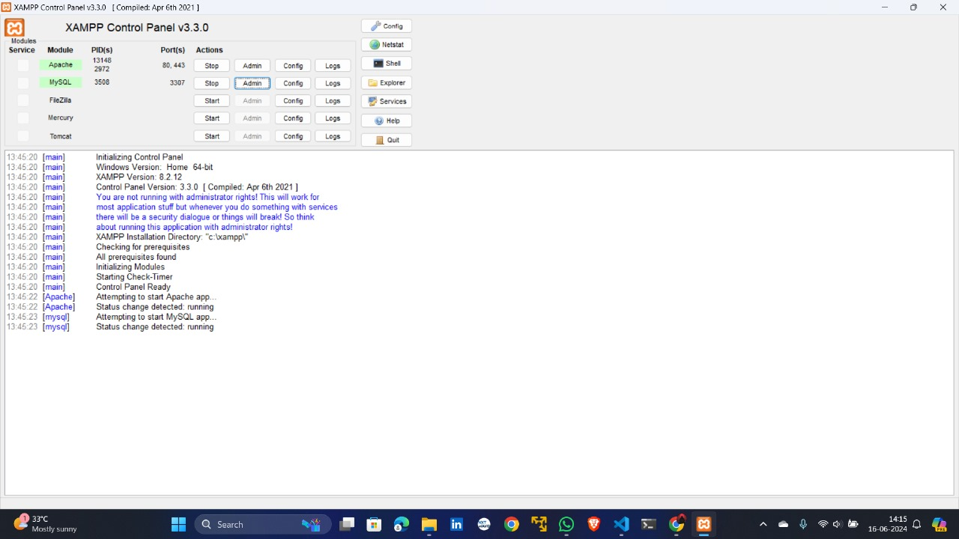

Figure 1 Start Apache and MySQL services using the XAMPP control panel.

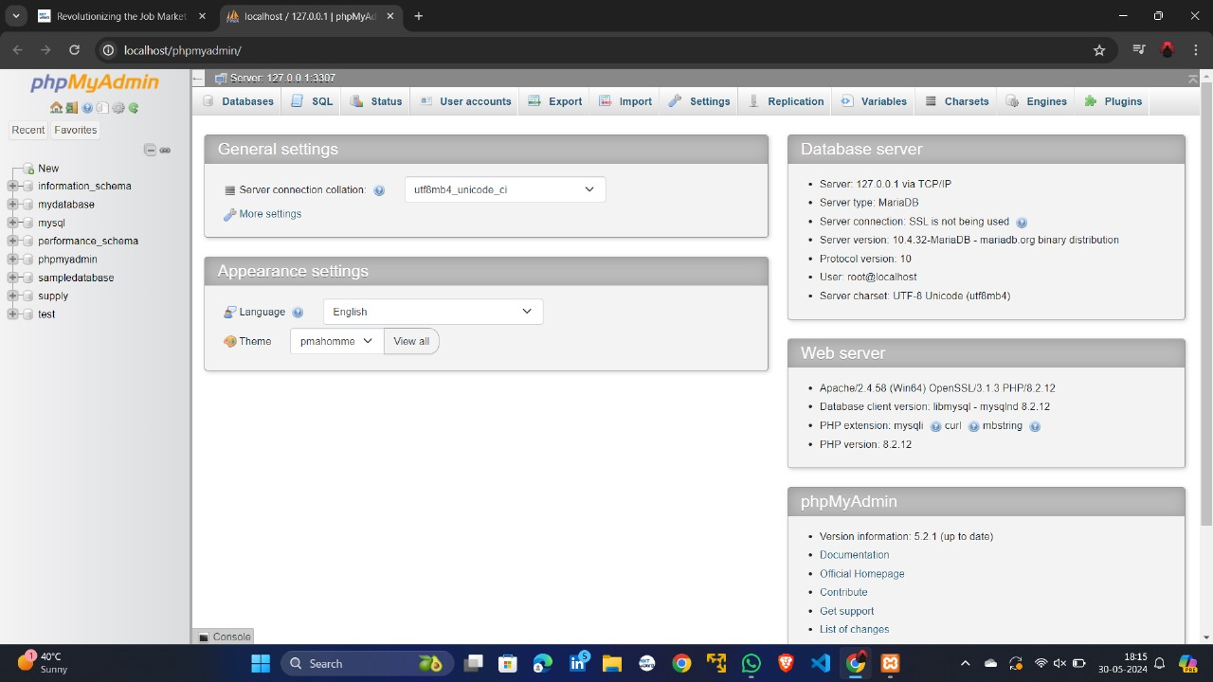

Figure 2 local host phpmyadmin live server which runs on our local machine

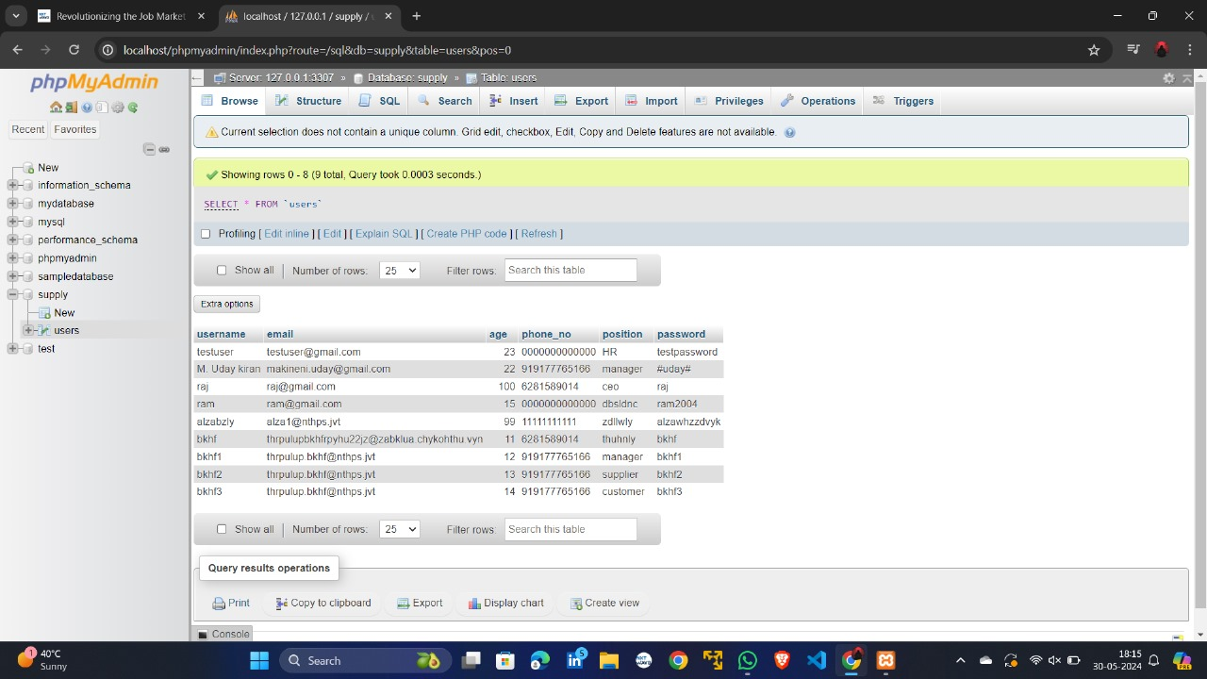

Figure 3 Our Live server 127.0.0.0:3307 with table name "users" which is located in supply folder

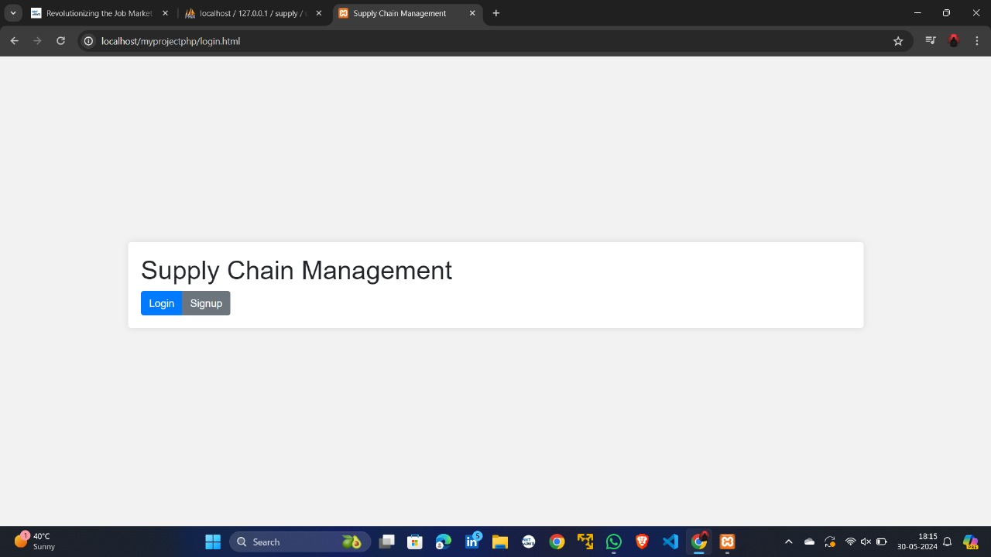

Figure 4 This is the landing page for our supply chain management system project

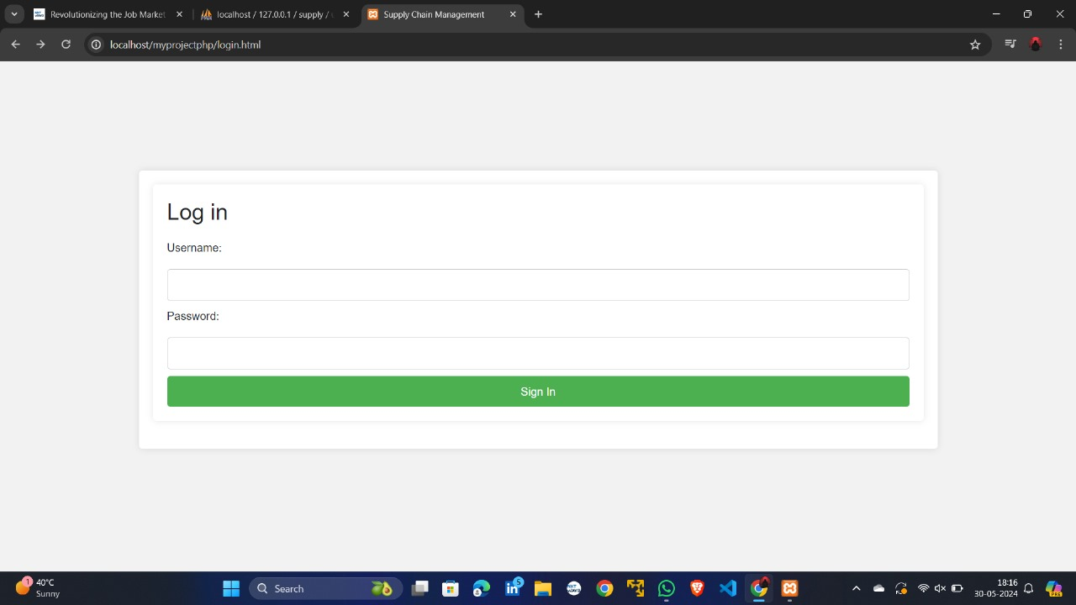

Figure 5 Login form

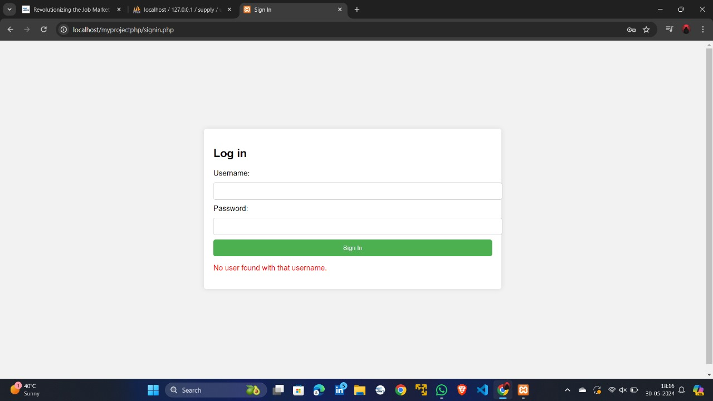

Figure 6 Error generated when an invalid user tries to login

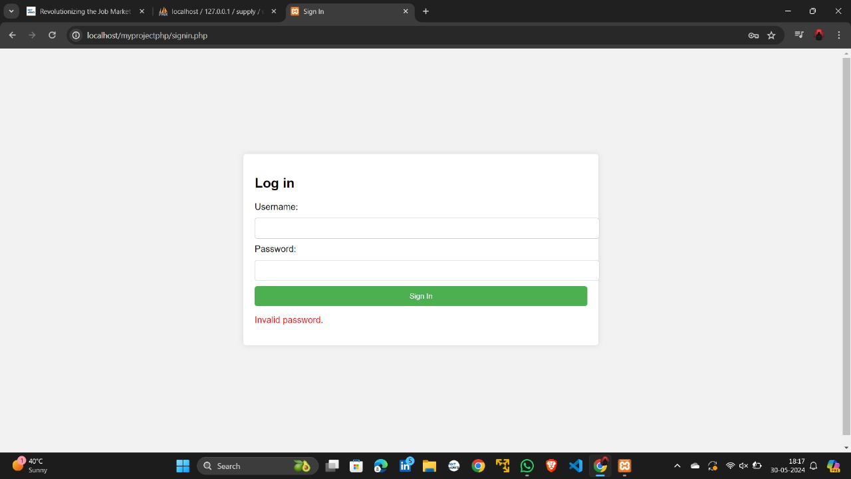

Figure 7 Error generated when an invalid password is tried to login

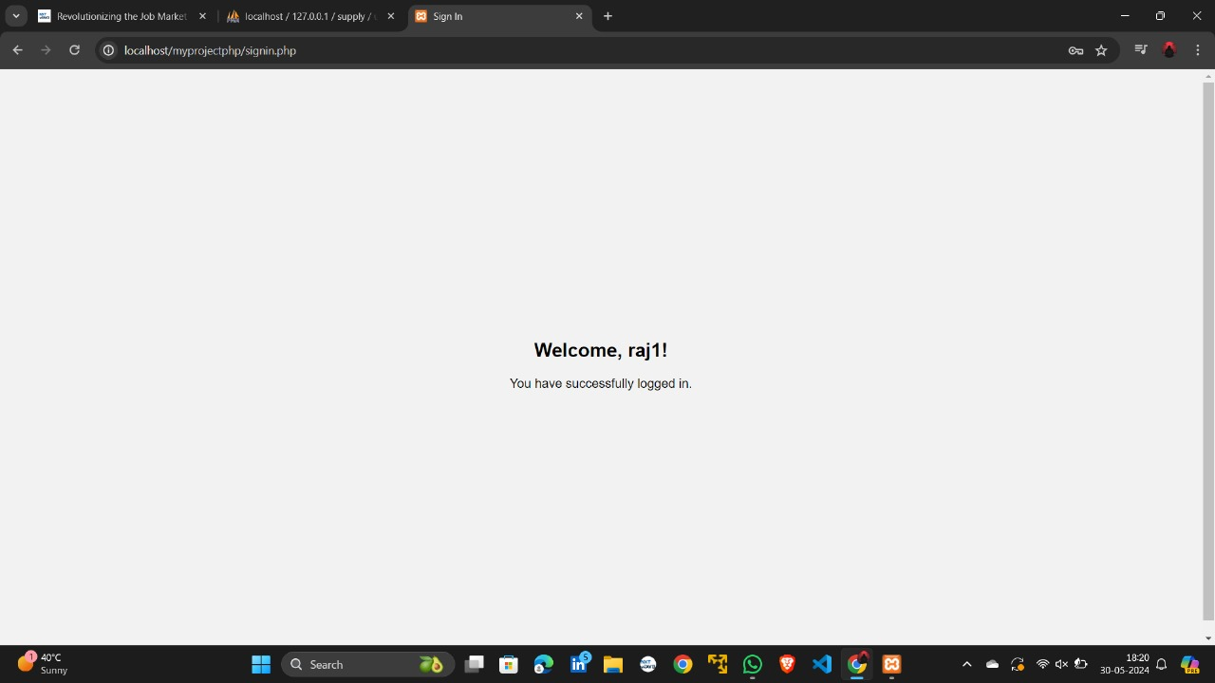

Figure 8 Welcome page after successful login

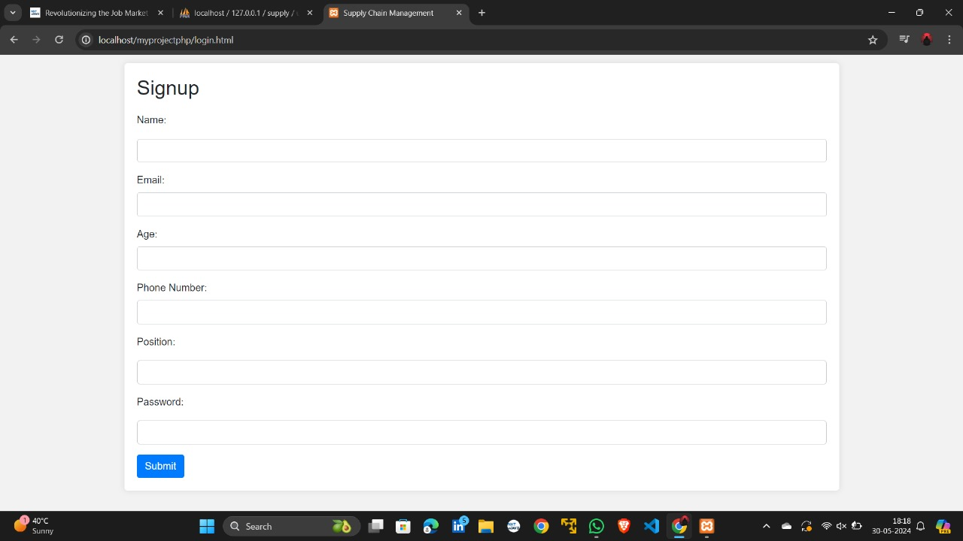

Figure 9 signup form

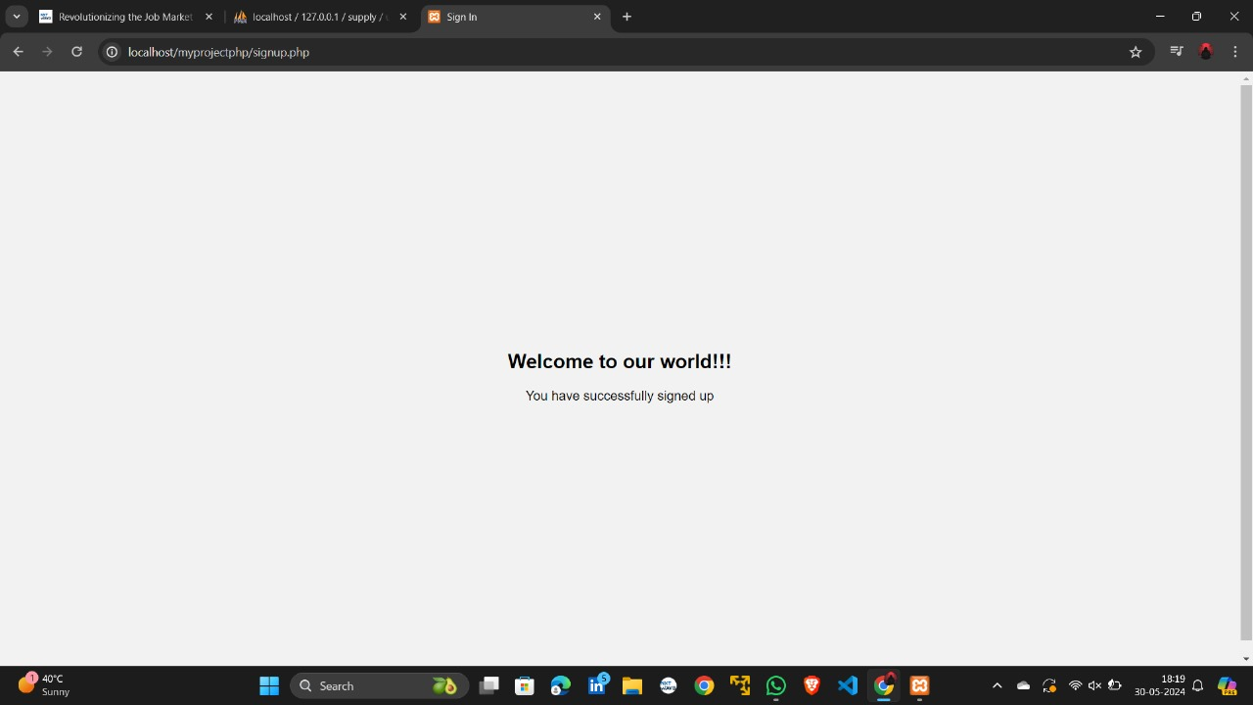

Figure 10 Welcome page after successful signing up

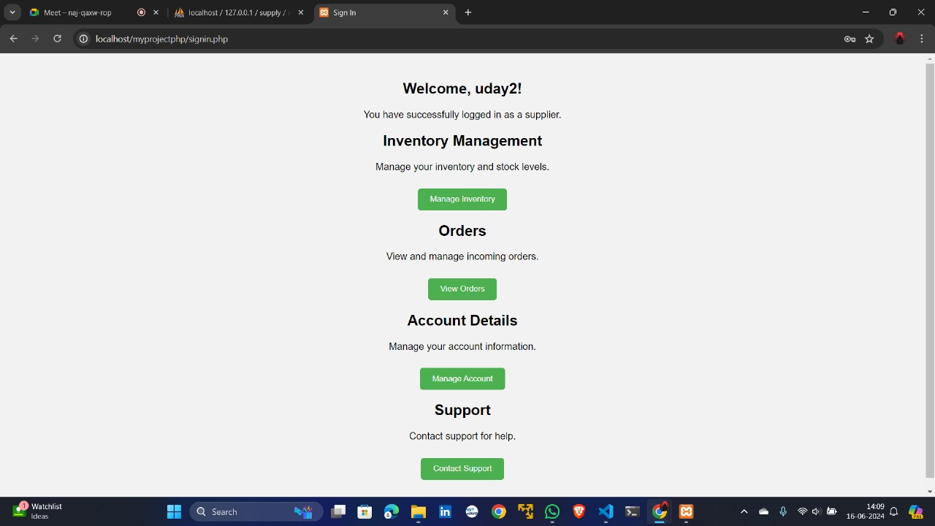

Figure 11 Home page of Supplier

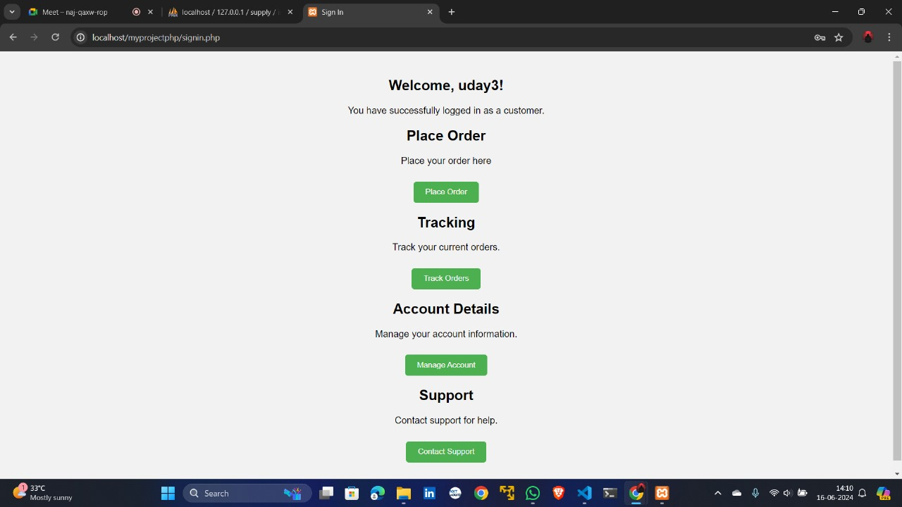

Figure 12 Home page of Customer

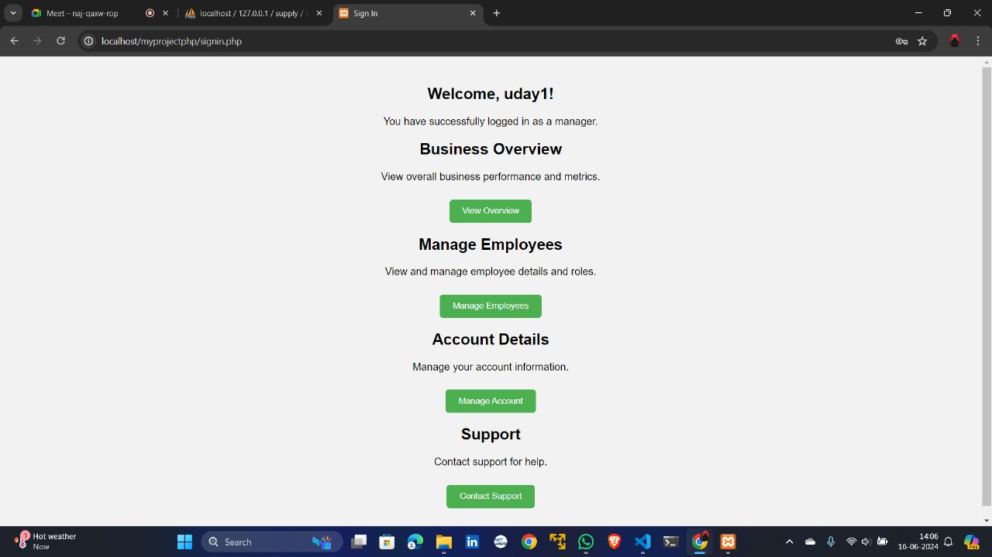

Figure 13 Home page of Manager

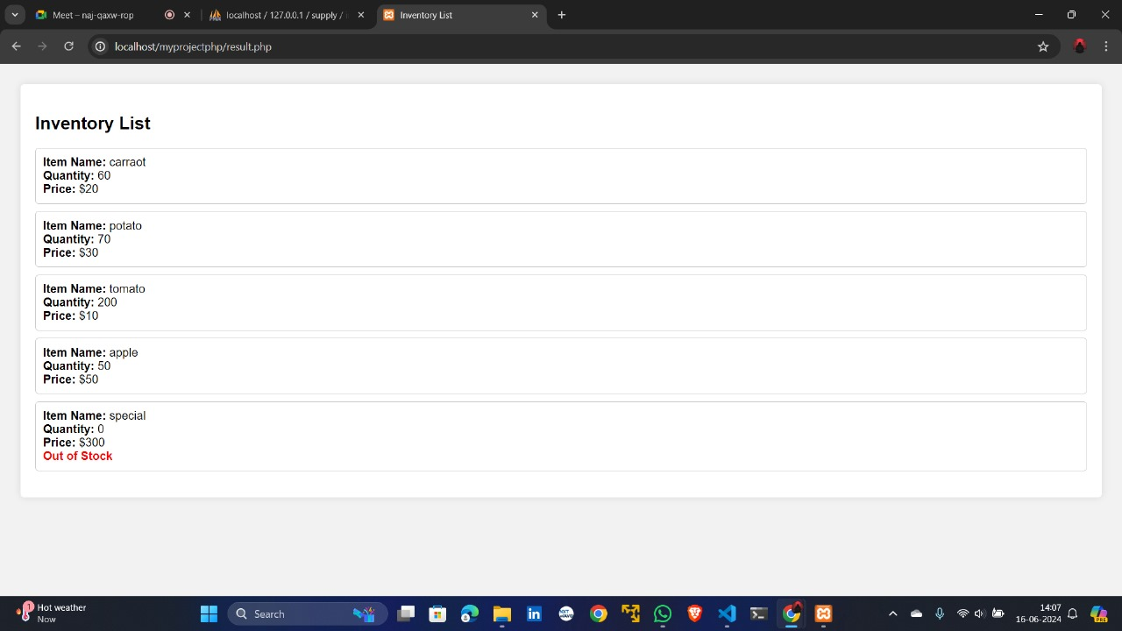

Figure 14 Business overview of Manager

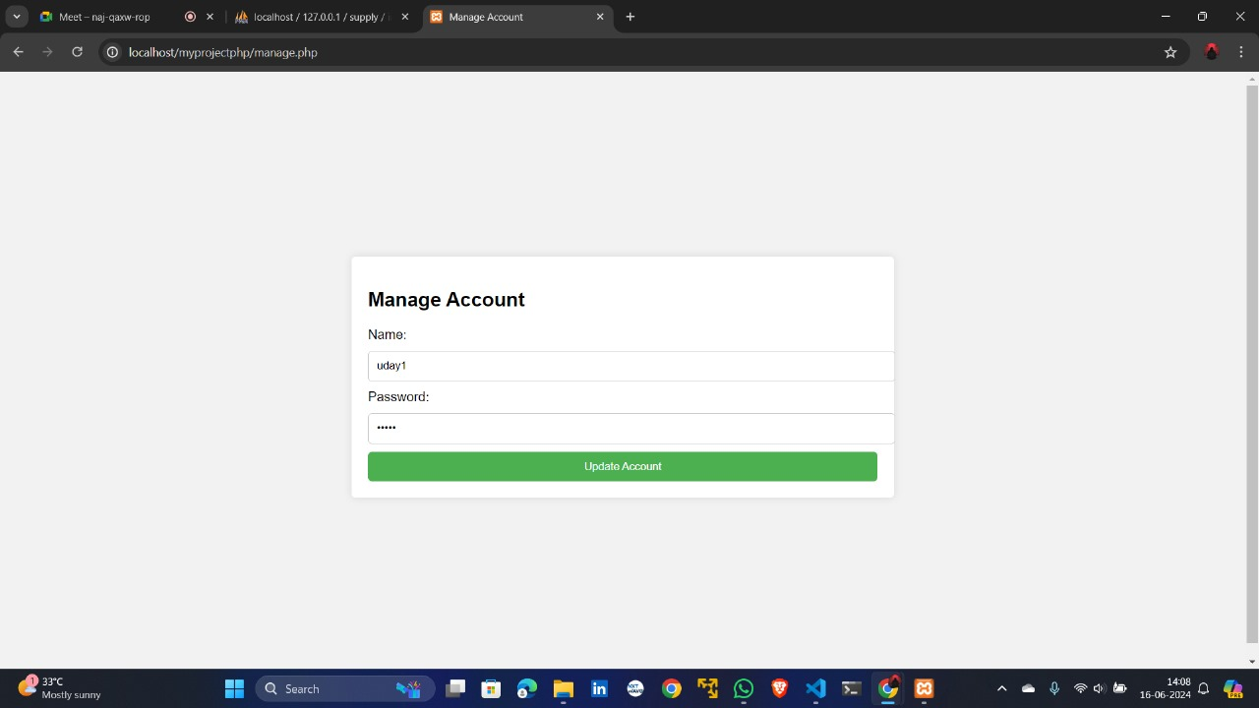

Figure 15 Manage account

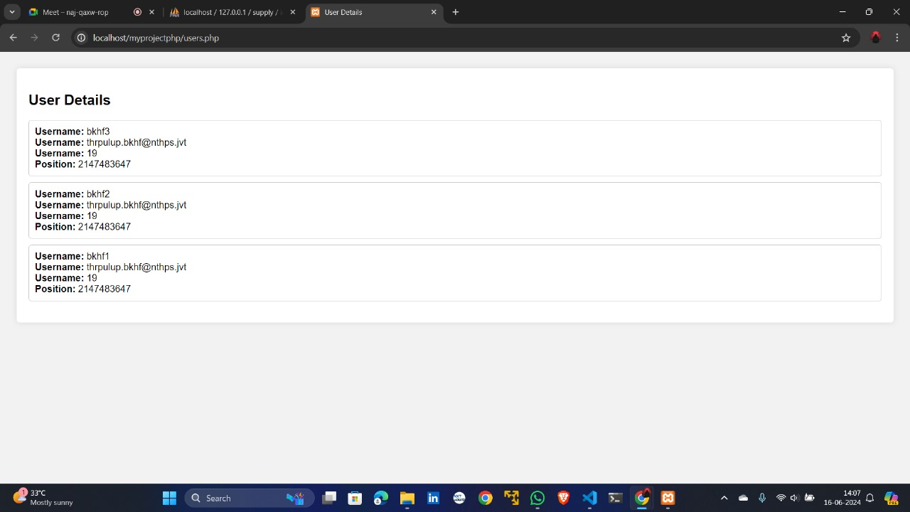

Figure 16 Manage Employees

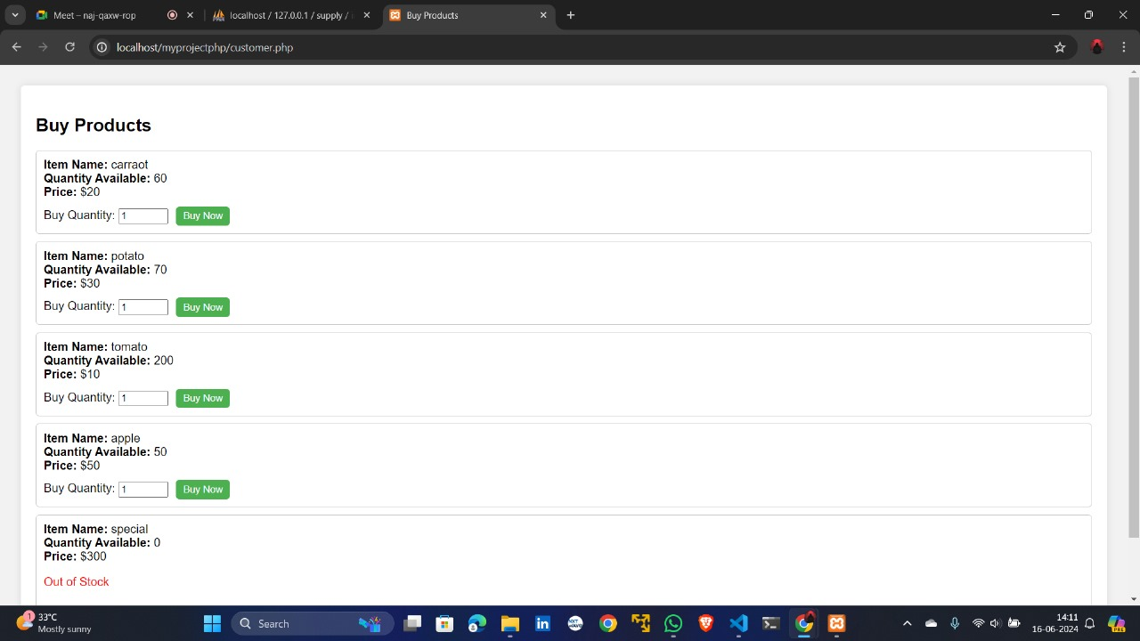

Figure 17 Place Orders

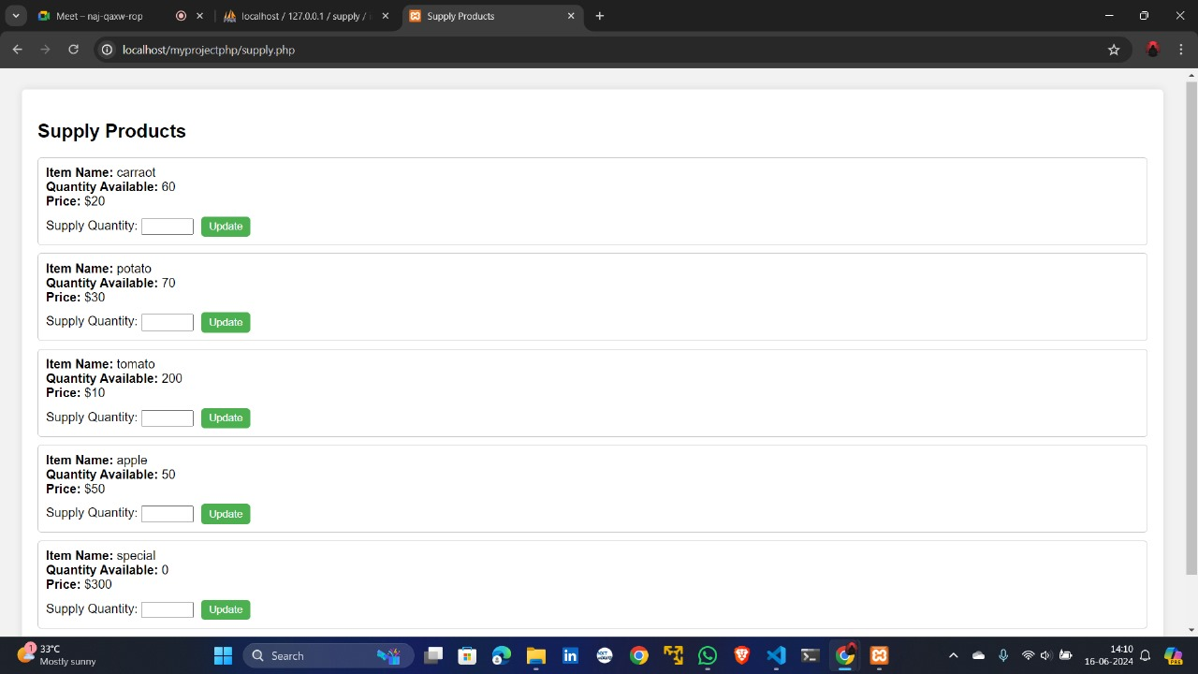

Figure 18 View Orders

**Different Output Analysis**

**Registration Success**

* Users are able to register successfully with encrypted data and passwords stored in the database.
* Upon successful registration, users are redirected to a success page.

**Login Success**

* Users are able to login with their credentials, with passwords being decrypted for authentication.
* Upon successful login, users are redirected to their respective dashboards based on their position.

**Role-Based Dashboard Display**

* Different users see different dashboards: managers can manage the supply chain system, employees can view and update tasks, and suppliers can manage supplies and orders.

**Results**

* The system successfully encrypts and decrypts user passwords and data.
* Users are authenticated correctly based on their decrypted passwords.
* Different dashboards are displayed according to the user's role.

**Challenges**

* Ensuring secure storage and retrieval of user passwords with encryption .
* Handling different user roles and directing them to the correct dashboard.
* Setting up and configuring XAMPP for local server hosting.

**Conclusion**

The project successfully demonstrates a secure user authentication system for a supply chain management application. It highlights the importance of data encryption and decryption for protecting sensitive information and provides a role-based user experience tailored to the specific needs of different users in the supply chain.

**Future Work**

* Implementing additional security measures such as HTTPS and two-factor authentication.
* Enhancing the user interface for a better user experience.
* Adding more functionalities to the dashboards based on user feedback.
* Deploying the application on a live server for broader accessibility.